Table of Contents

Introduction 2

TOPOLOGY 2

Part A 3

Saving Packet tracer 3

Adding IoT Registration Server 3

Enable the Registration server 4

Configure the registration server 5

Setup wireless Router 6

Register Tablet to the Registration Server 8

Configure the Smart Devices to register with your Registration Server 9

Smart Door 9

Garage Door 13

Motion Detector 14

Air Conditioner (AC) 15

Portable Music Player 16

Carbon Monoxide Detector 17

Smart Thermostat 18

Smart Siren 19

Fan 20

Smart Lamp 21

PART B 23

Lock the Front Door 24

Open the Garage door 24

Play 'music' through the Portable Music Player 25

Unlock the front door 26

Test the siren 26

Switch on the Air Conditioner 27

PART C 28

When the motion detector detects motion, set off the alarm and lock the door. 28

Increase the carbon monoxide level and open the garage door (it should also close when the level reduces). 29

References 31

# Introduction

Packet tracer from Cisco is a robust simulation tool that visualizes networks. Using Packet Tracer, we can build a network from scratch, use a pre-constructed sample network, or do lab assignments in class. It allows you to easily find out how data travels through your network using Packet Tracer. Without expensive lab equipment, Packet Tracer allows you to design and build networks of any size. This software provides too many benefits to ignore, even though it cannot replace physical outers, switches, firewalls, and servers. An extensive use of packet tracer is found in networking and modelling of the internet of things (IoT).

(Packet tracer faqs,2022)

As an IoT Developer at Home Of The Brave, I am responsible for setting up an IoT home office and a head office with a remote link. First, I created a home office in Byron Heads and connected them all to a remote server so I could access them from my tablet. Then I created a head office in a different city called Brispain and connected it through an ISP. In the head office, all the home office devices are controlled by a tablet device. To maintain the devices I have applied the given condition to the remote server.

## TOPOLOGY

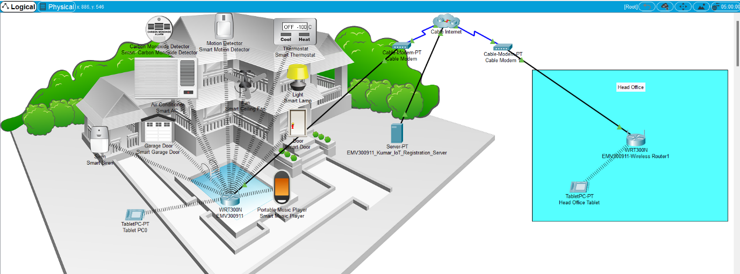

Figure 1: Topology

**File**



# Part A

For the completion of this task, I will connect the home office to the ISP using a cable modem. After that, I will enable and configure the registration server, tablet, and wireless router for the home office, and I will maintain all the security protocols and techniques.

## Saving Packet tracer

As a first step, I have downloaded the packet tracer file from the provided link and saved it as **EMV300911 HI6041**

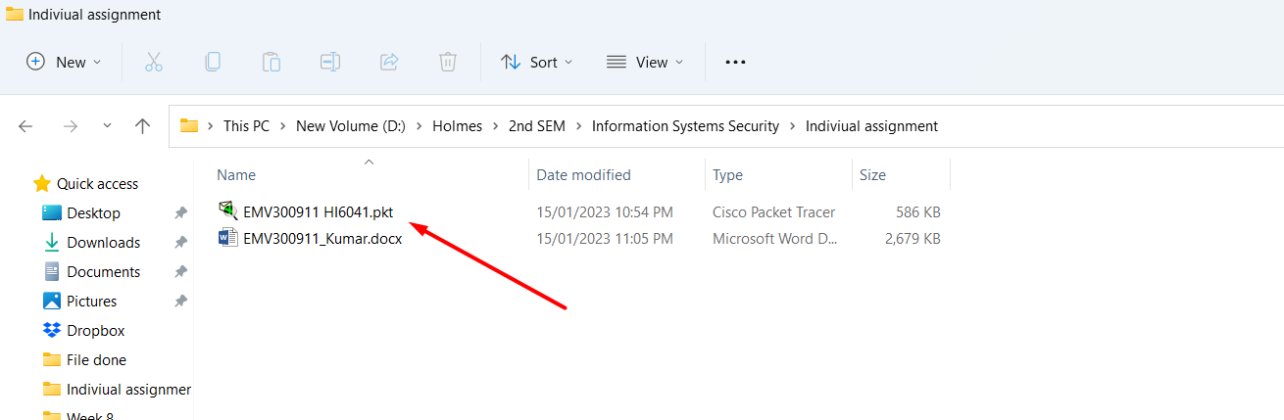

Figure 2 Downloaded and saving packet tracer

## Adding IoT Registration Server

In order to add the Registration server, select an end device from which you can see the server, select the server, and drag it to the workplace.

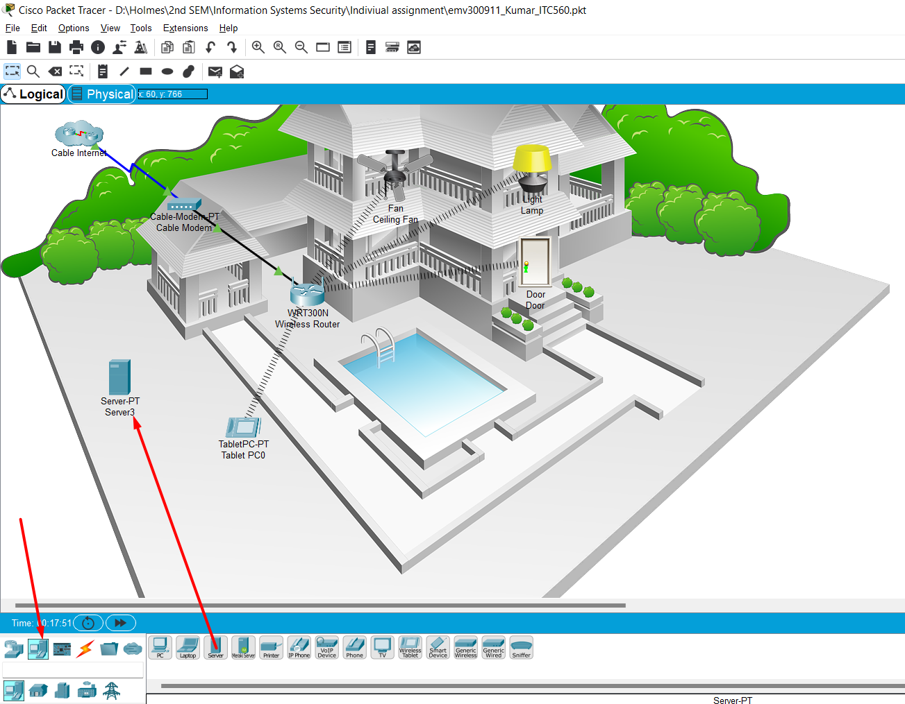

Figure 3: Adding IoT registration Server

To connect the IoT server, choose a **Straight-Through** wire and connect it to the cloud. Finally, the server is connected to the wireless router via cable internet and cable modem.

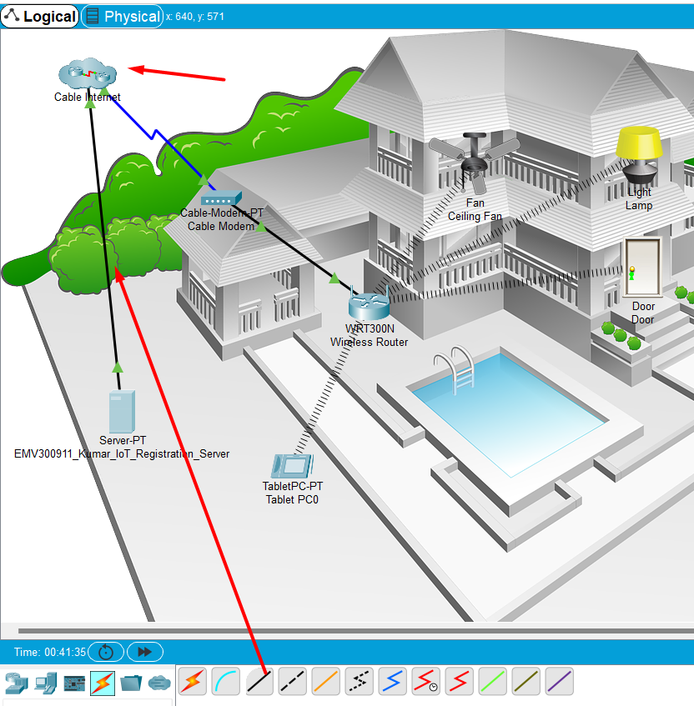

Figure 4 connecting wire with coper Straight-Through

## Enable the Registration server

The IoT service must be enabled as it is off by default. To enable it, we must first click on Registration server and then click on the **Services** tab, where we will find **IoT** service on the left side. Here we will need to enable the service by selecting a button as shown in the image below.

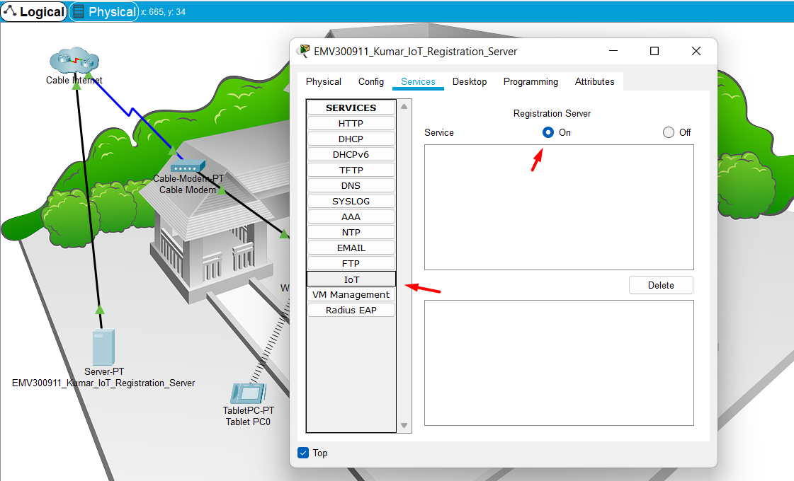

Figure 5: Enable registration server

## Configure the registration server

Select the config tab and change the name to EMV300911_Kumar_IoT_Registeration_server. Then, select fastethernet0 where we have assigned a static IP address.

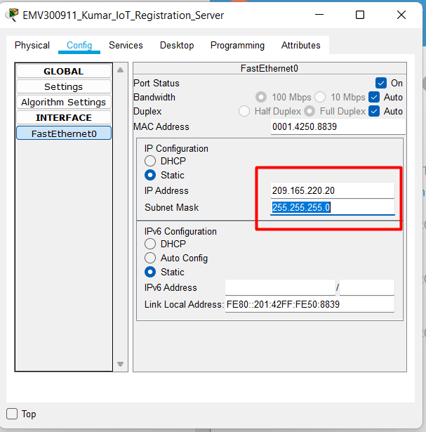

Figure 6: assigning static IP address for IoT server

For resolving the names of the devices in the given environment, I have created a DNS name server after configuring the IoT server. The device has been connected to the DNS name server "www.kumar.com.".

**Steps**: First double click on the server then select the **Services tab, then** click **DNS** server which is located on the left sidebar. After that click on the **On** button to enable **DNS** service. Provide the domain name in the Resource Records section, and the IP address of the IoT server in the Address section. Finally, click on the **add** button.

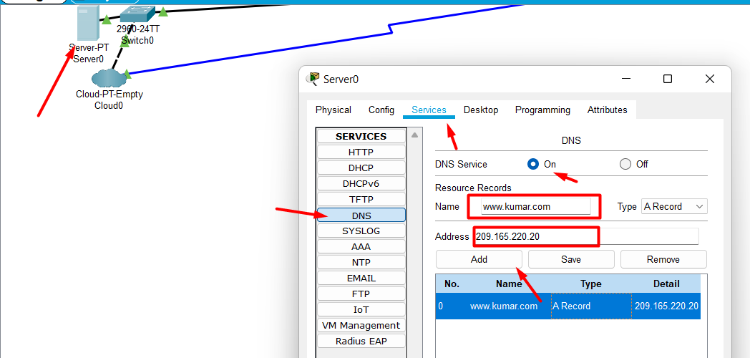

Figure 7: Creating DNS server

## Setup wireless Router

Double click on the wireless router. After that a box will appear where we need to click on **config** tab then on the left side we can see the setting click it and change the name of the wireless router to **EMV300911**

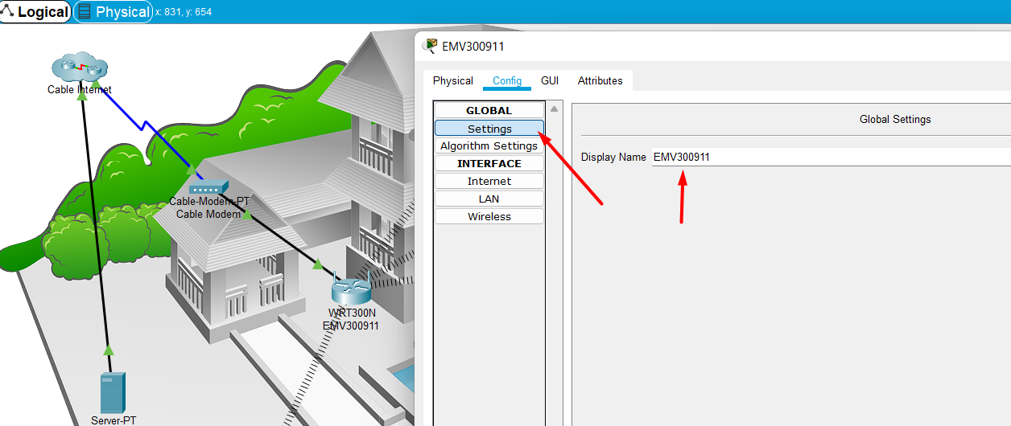

Figure 8: Changing the name of wireless router

After changing the name click on the **wireless** tab. Change the SSID to **OfficeNet ,** then for authentication I have selected **WPA-PSK** and I have set the password “**EMV300911**” for the encryption option I have selected **AES**.

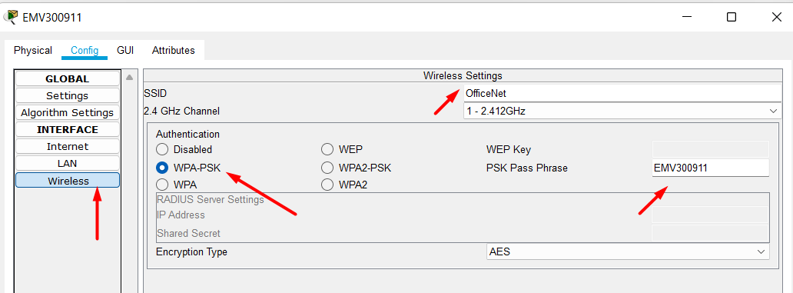

Figure 9 Wireless router configuration

## Register Tablet to the Registration Server

To register tablet first double click on tablet icon then click on the **desktop** tab. Then select the web browser from the option and enter “www.kumar.com”

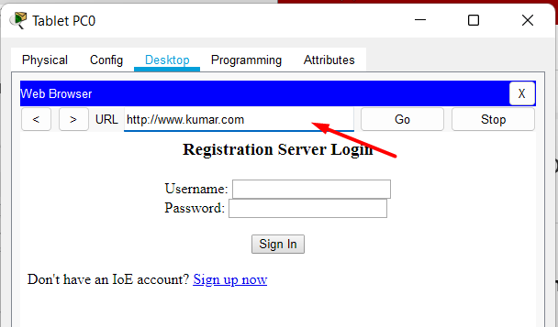

Figure 10: Accessing IoT server

As we don’t have an account we need to create IoT account. For that click on signup and create an account with username/password: **EMV300911**

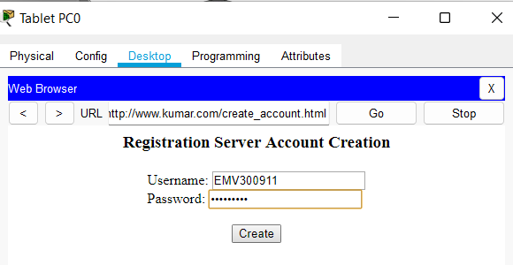

Figure 11: Creating Account

Since we did not set up a smart device, we cannot see any devices at the moment. So let’s set up the smart device and then we will check it again.

## Configure the Smart Devices to register with your Registration Server

### Smart Door

Double click the smart door, when a pop-up box appear click on advanced button

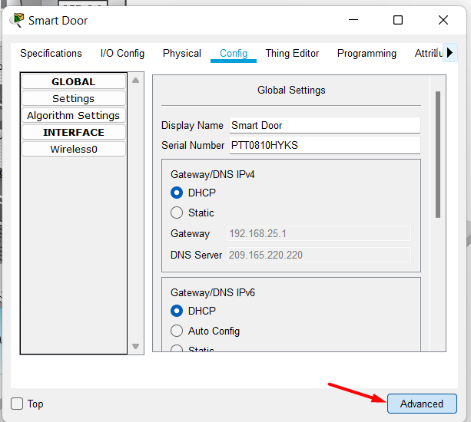

After that click on I/O config tab, from Network Adapter drop down option choose PT-IOT-NM-1W (this is a wireless network adapter)

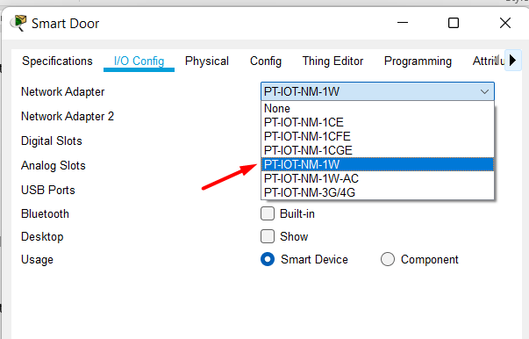

Now click on the config tab to change the name of the device and select DHCP for getting an automatic IP address.

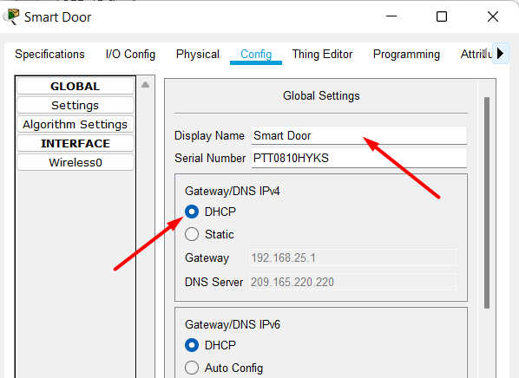

Figure 12: Changing door name and selecting DHCP

After that click on the wireless tab. Change the SSID to **OfficeNet ,** then for authentication choose **WP-PSK** once you select this option you need to set the password which is “**EMV300911**”. Encryption can be configured by selecting AES encryption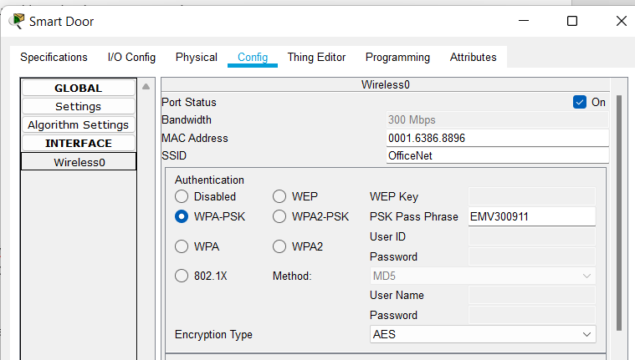

Figure 13: Connecting Smart Door to Router

Moreover, we need to config Remote server. To access the remote server click on **config** tab find IoT server section and provide the IP address(209.165.220.20) of IoT Server or DNS address(www.kumar.com). After that proved the username and password which is “EMV300911”.

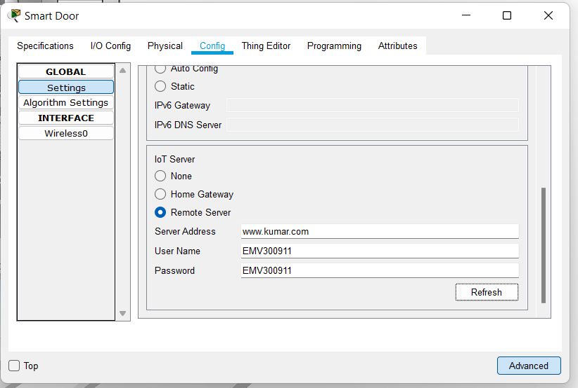

Figure 14: Connected smart door to the IoT server

The smart Door has been successfully connected to the router. All other **smart devices** must be connected by following the same procedure as we followed to connect the door

### Garage Door

By following the same procedure which was followed to connect the Door, I had successfully connected the smart Garage Door which is shown below. In the picture below, we have shown how to **configure** the **Garage Door** and how to connect to the IoT server.

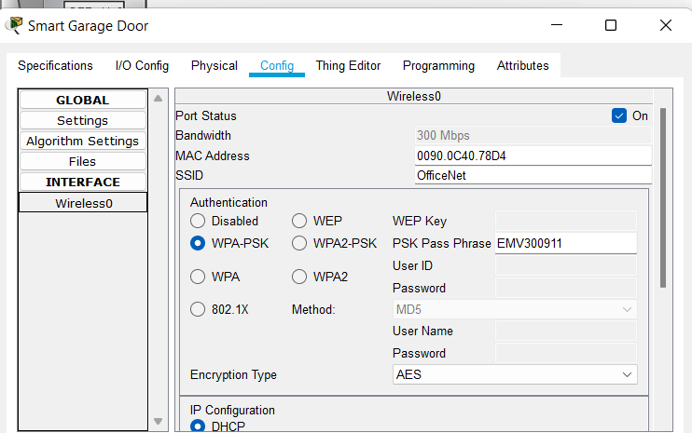

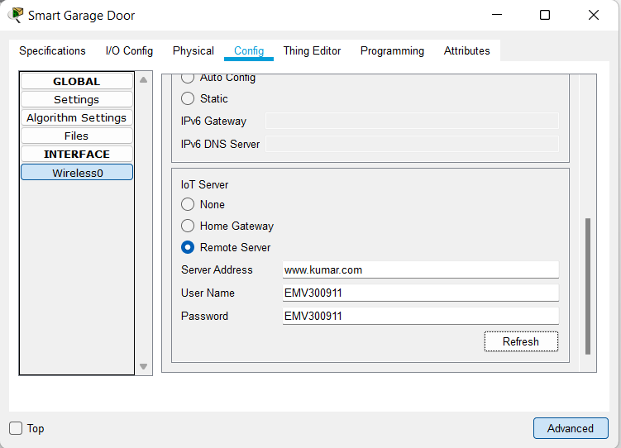

### Motion Detector

In the picture below, I have shown how to configure the smart **Motion Detector** and we have successfully connected to the IoT **server.**

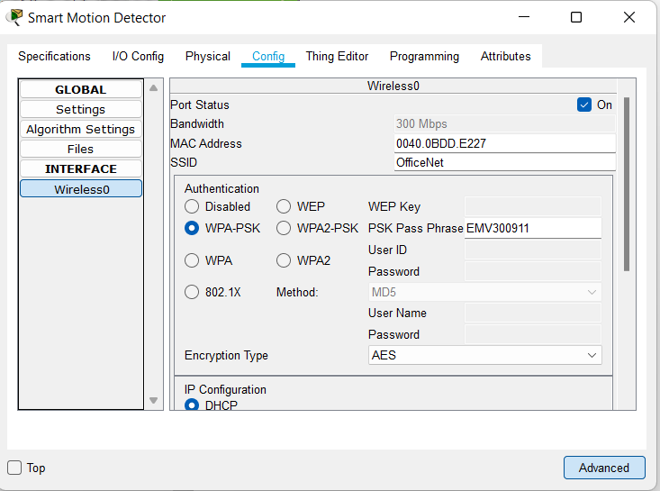

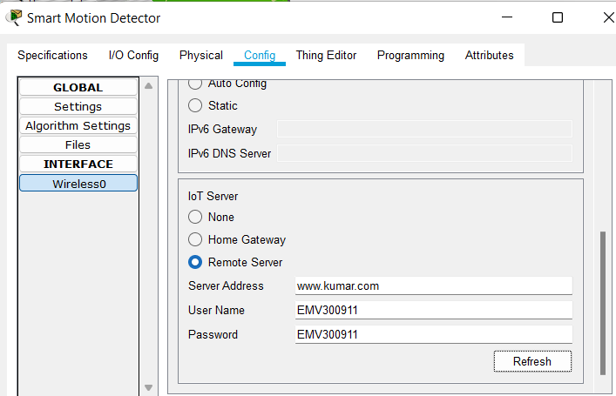

### Air Conditioner (AC)

In the picture below , we have shown to **config** the smart **AC** and we successfully connected to **IoT server.**

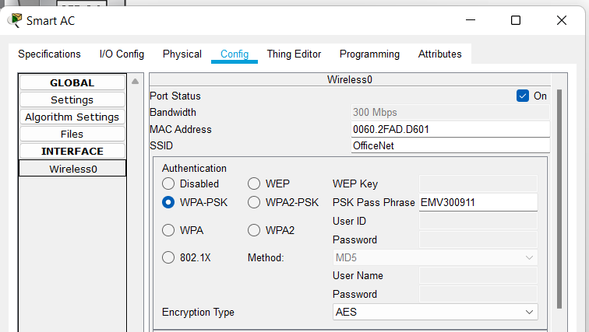

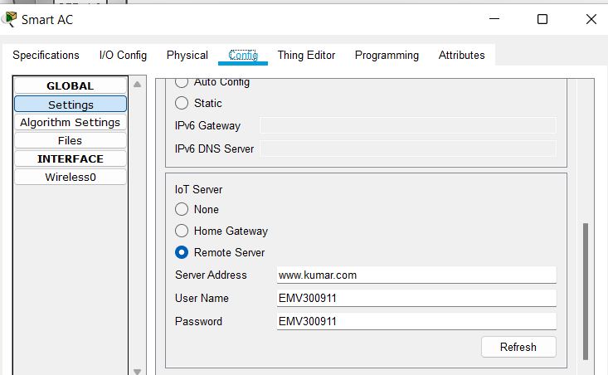

### Portable Music Player

In the picture below , we have shown to **config** the smart **Music Player** and we successfully connected to **IoT server.**

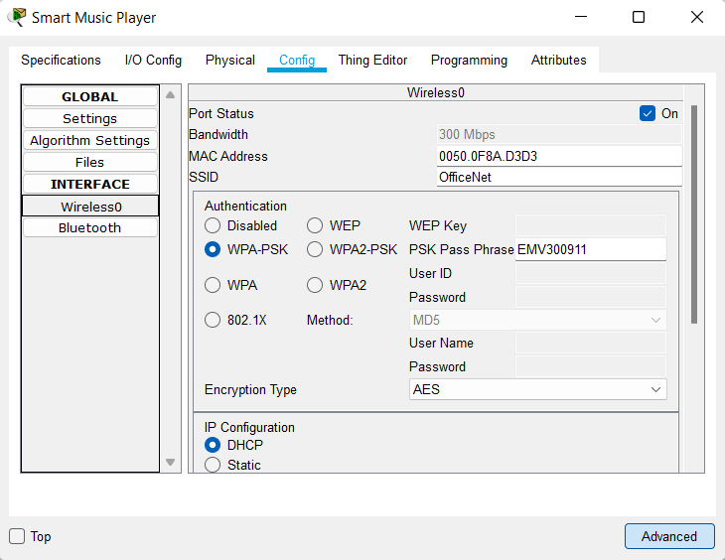

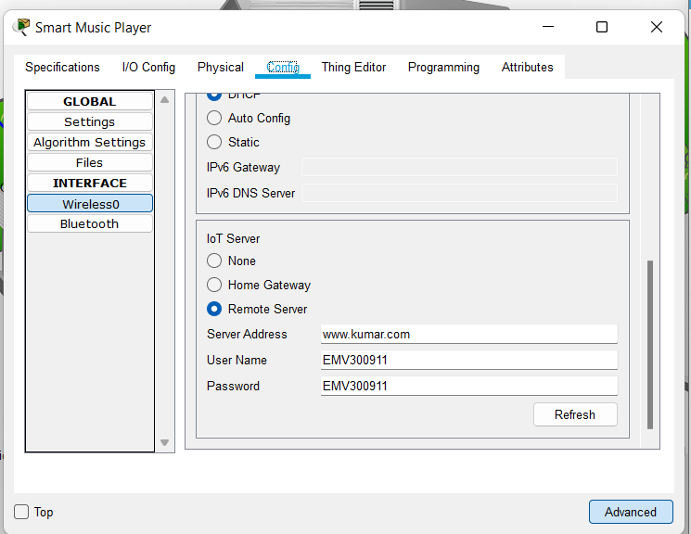

### Carbon Monoxide Detector

In the picture below , we have shown to **config** the smart **Carbon Monoxide Detector** and we successfully connected to **IoT server.**

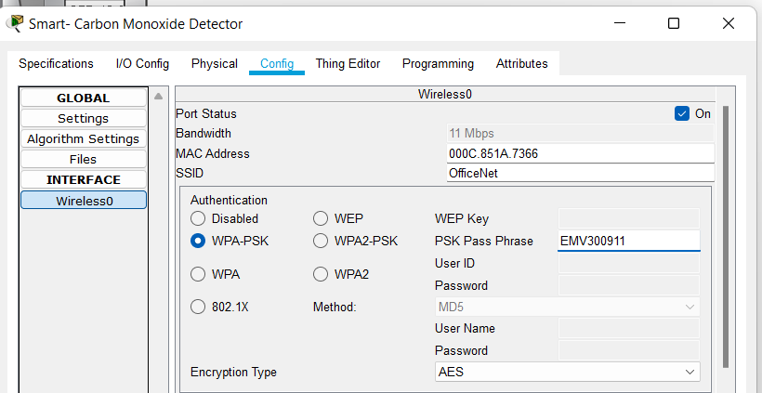

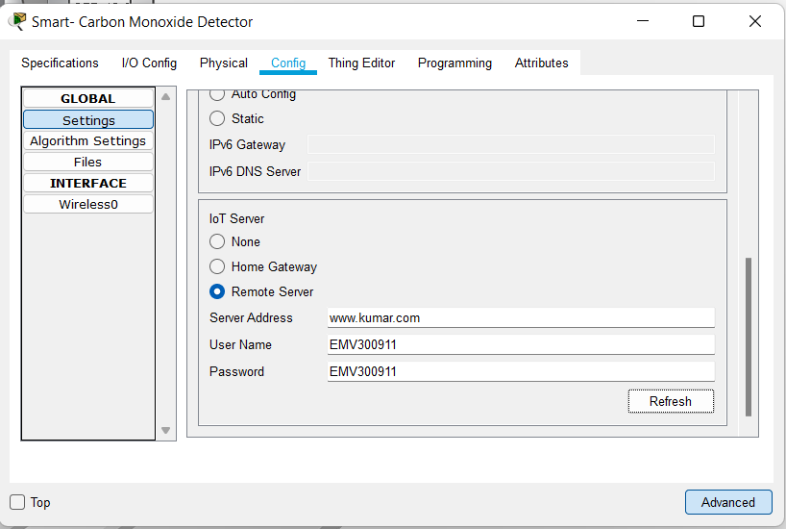

### Smart Thermostat

Below is a picture showing how to configure the smart **thermostat** and connect to the IoT **server.**

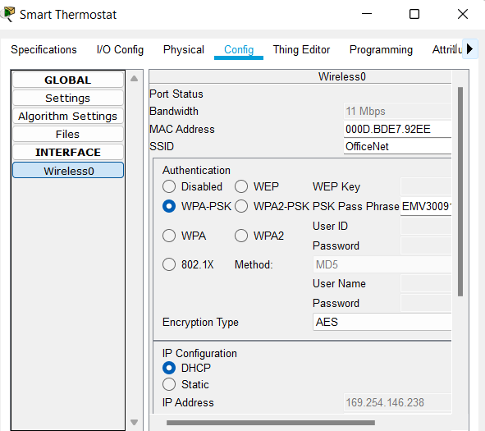

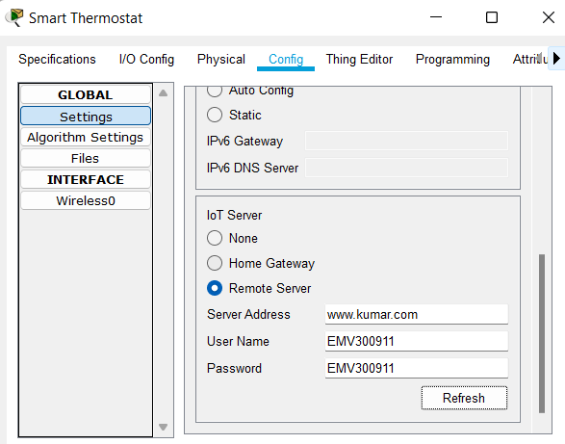

### Smart Siren

Below is a picture showing how to configure the smart **Siren** and connect to the IoT **server**.

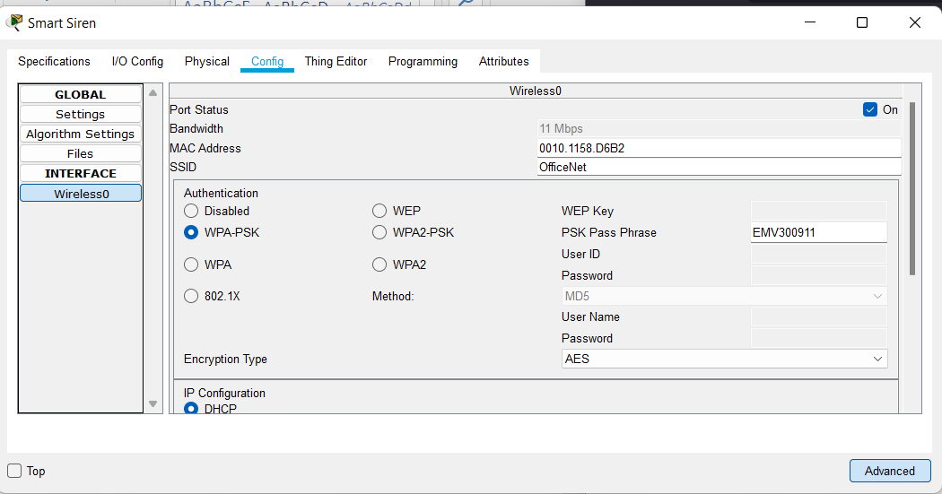

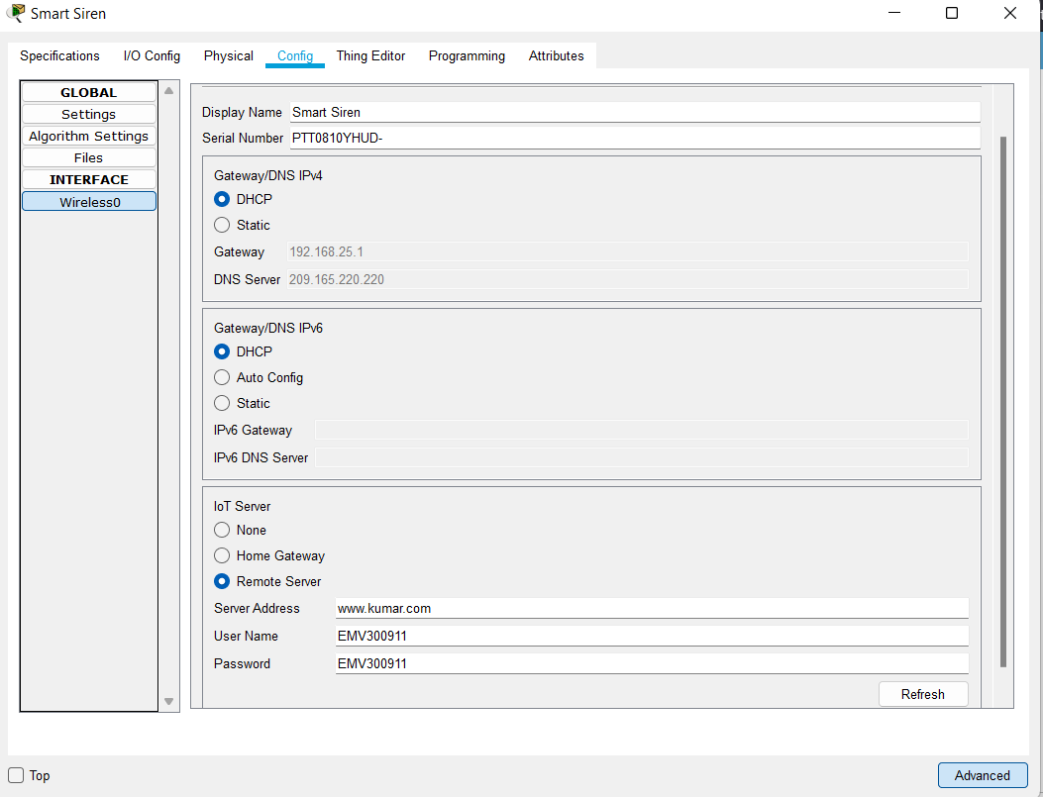

### Fan

Below is a picture showing how to configure the smart **Fan** and connect to the IoT **server**.

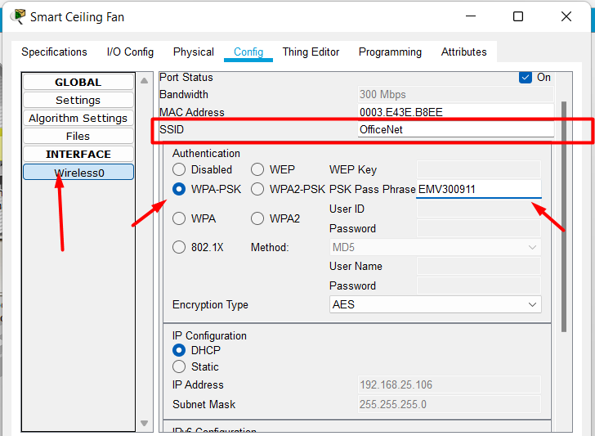

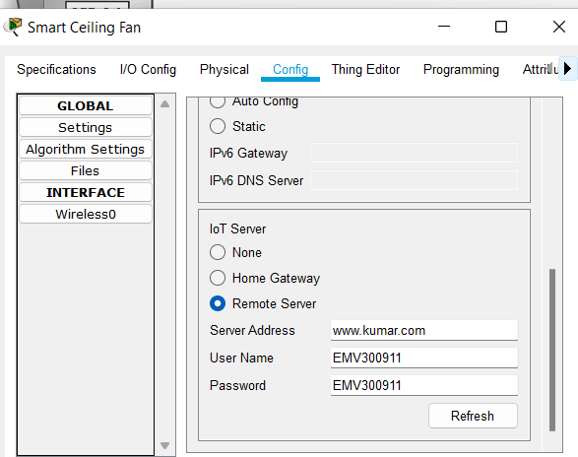

### Smart Lamp

Below is a picture showing how to configure the smart **Lamp** and connect to the IoT **server**.

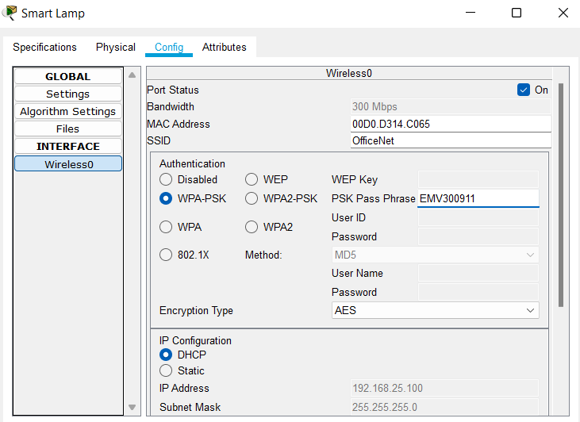

Figure 15 connecting smart Lamp to the router

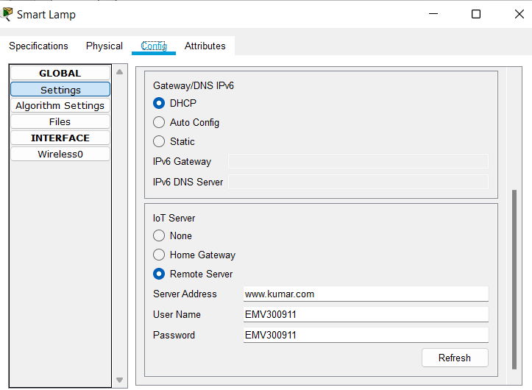

Figure 16: connecting IoT server

**Checking Smart devices from Tablet PC0 which is in Home Offfice**

Here we can see all the device are successfully connected and we can control each device from tablet.

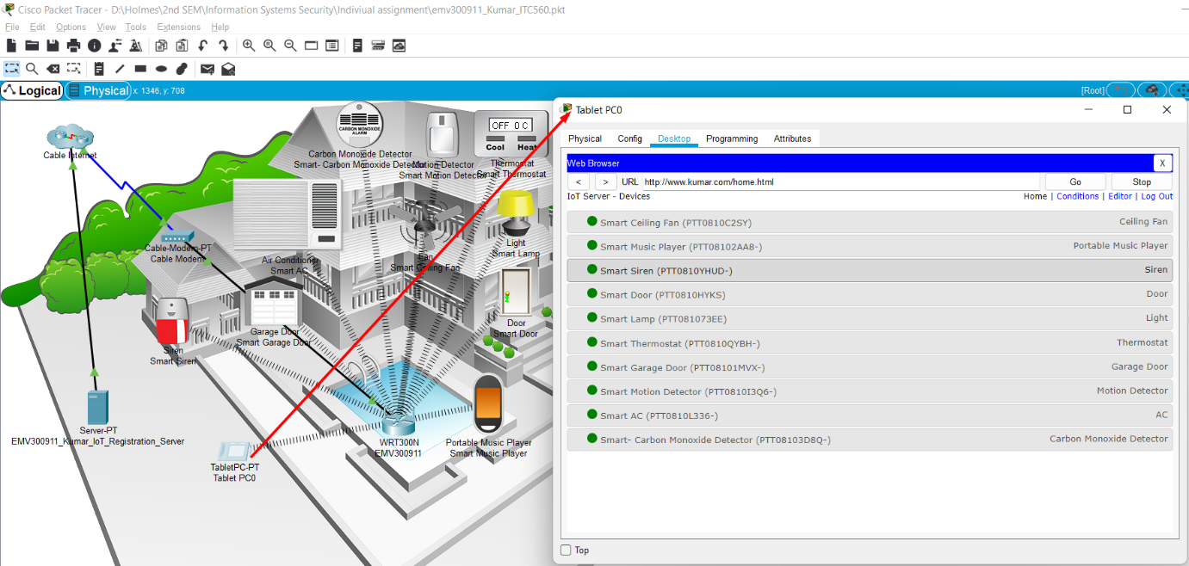

Figure 17 All IoT device on the server

(Artigas, 2020)

# PART B

Here, I have added a **head office** in another city, and then I have added a tablet, titled "**Head Office Tablet**," which is connected to the Internet provider. One can access the IoT server and control smart devices at home using this tablet.

**Topology of head office**

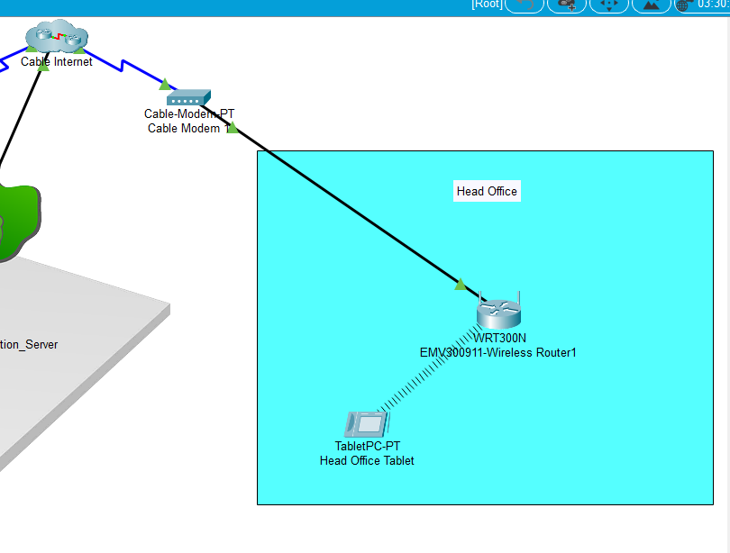

Figure 18 Topology

## Lock the Front Door

To lock the front door from head office first we need to open the web browser from a tablet and access the web address which is “www.kumar.com” then we need to sign in there entering the Username and password which is **EMV300911,** then we have to find the smart door. Once you see the smart door double click on it. There you can see two options: lock and unlock. To lock the door just click on the lock option.

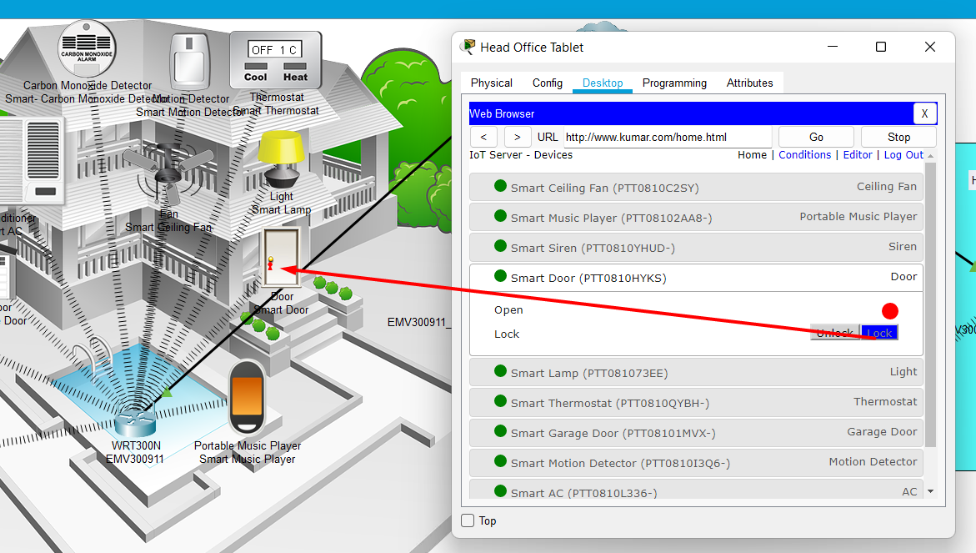

## Open the Garage door

First we will access the IoT server through a web browser then we will open the garage door. In the below picture we can see that the garage door is initially locked. After I clicked on the button, the button turned green and the door opened.

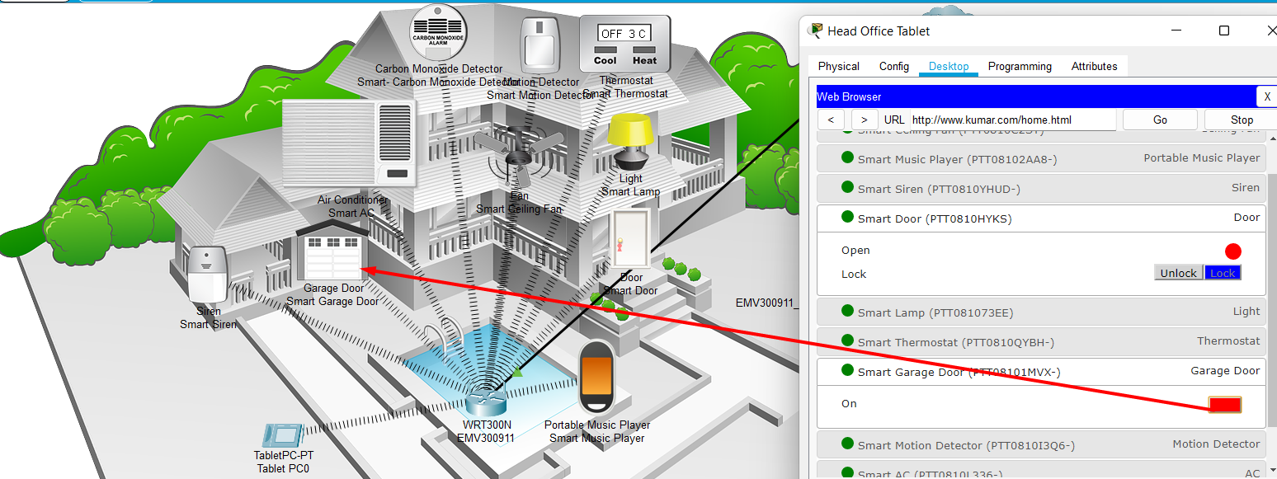

Figure 19: Garage door close

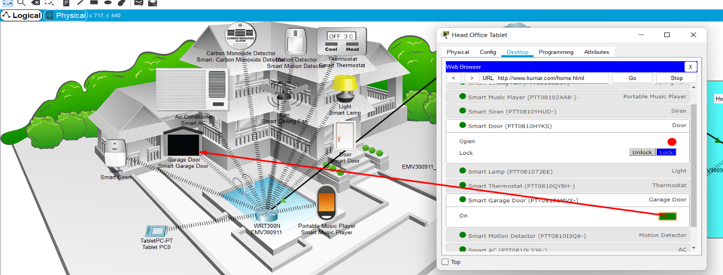

Figure 20: Garage door open

## Play 'music' through the Portable Music Player

To turn on and play the music player you just need to click the button so that the button colour changes from red button to green

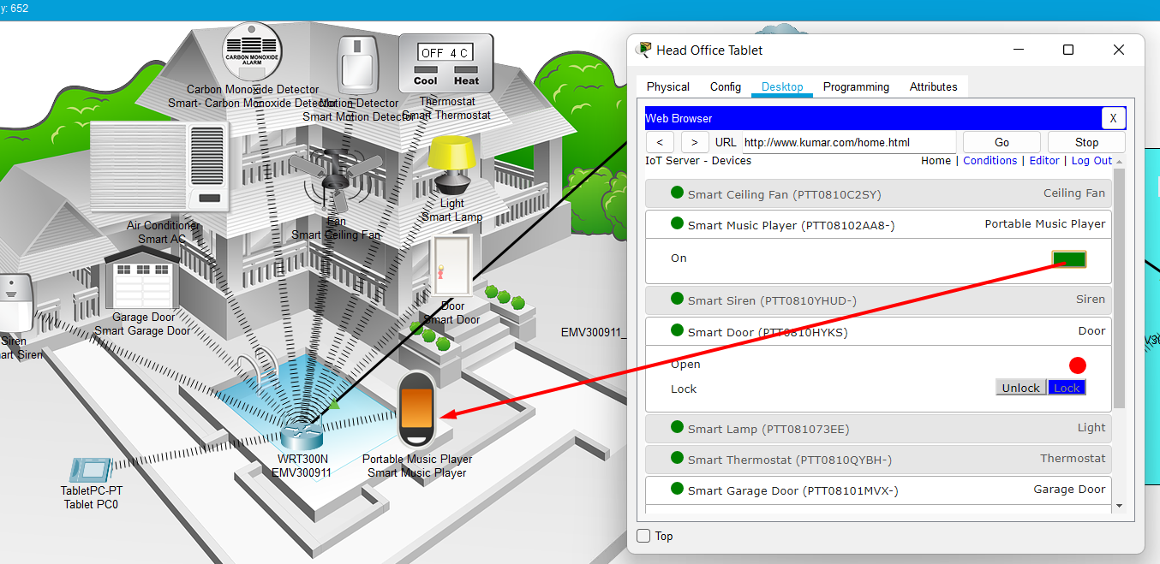

Figure 21: Music Player is on

## Unlock the front door

Navigate to the smart door and select the unlock button. After that, the status of the front door will change from red to green.

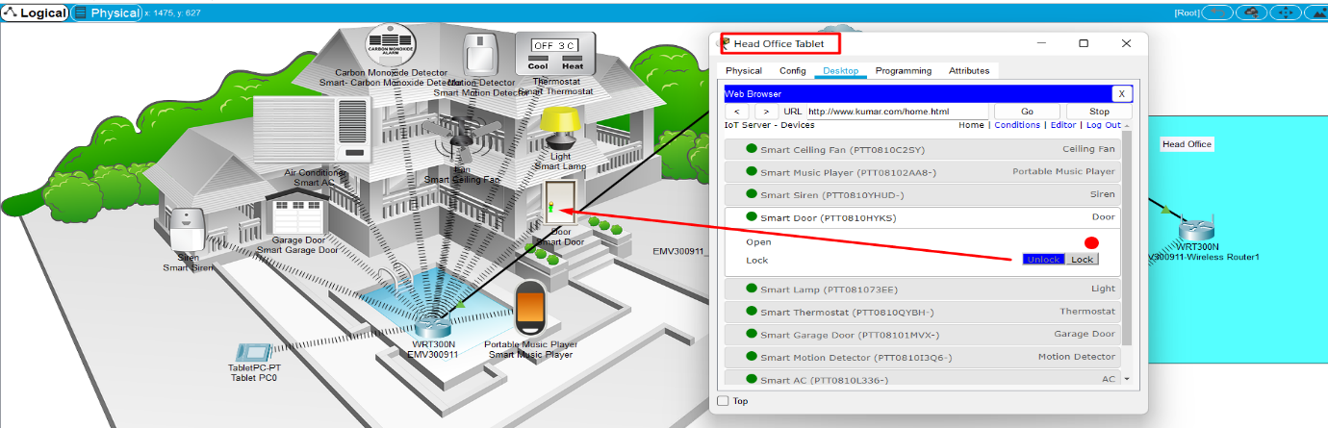

Figure 22: Front door unlock

## Test the siren

In the beginning, the siren is off, and the button in the web browser is red, but when we click on it, the button turns green and the siren icon in the home office becomes red.

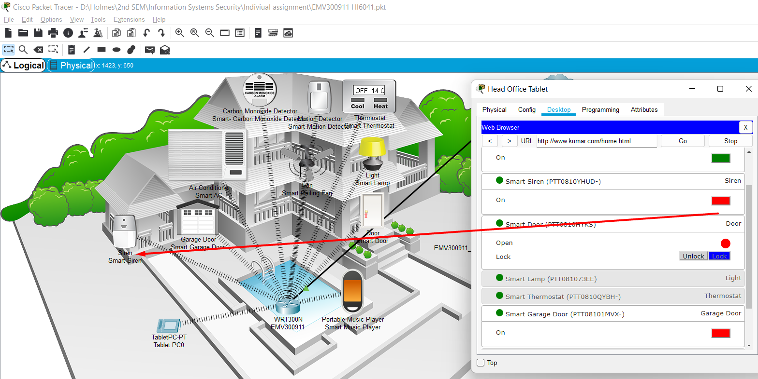

Figure 23: siren off

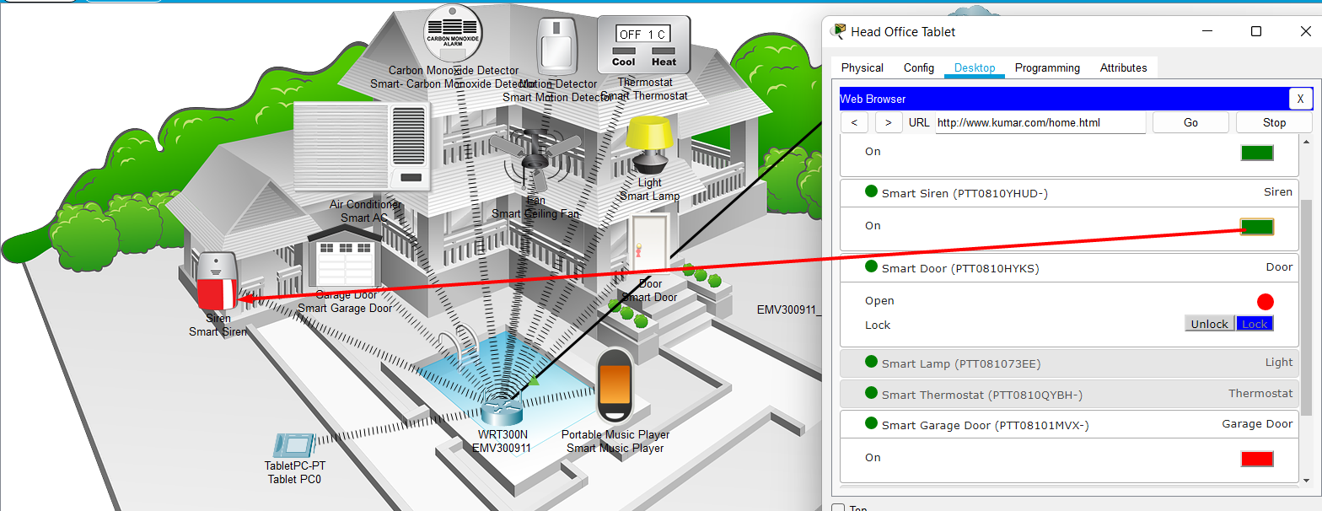

Figure 24: Siren On

## Switch on the Air Conditioner

Below in the picture where we can see how one can turn on the Air Conditioner

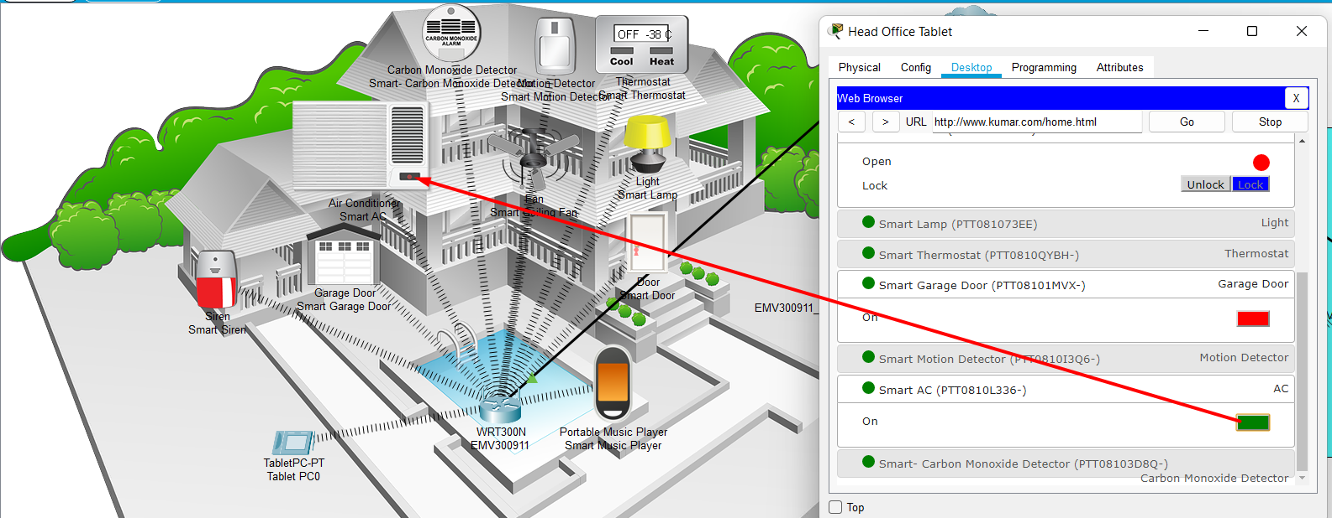

Figure 25: Air Conditioner On

# PART C

## When the motion detector detects motion, set off the alarm and lock the door.

Following are the steps to apply the condition

1. Login to the IoT server using the credential “EMV300911”
2. Click on a condition
3. Click on add condition
4. Then we give a name for our condition “Motion Detects”
5. Then we will setup the condition as shown in the given picture. Once you fill the condition click ok

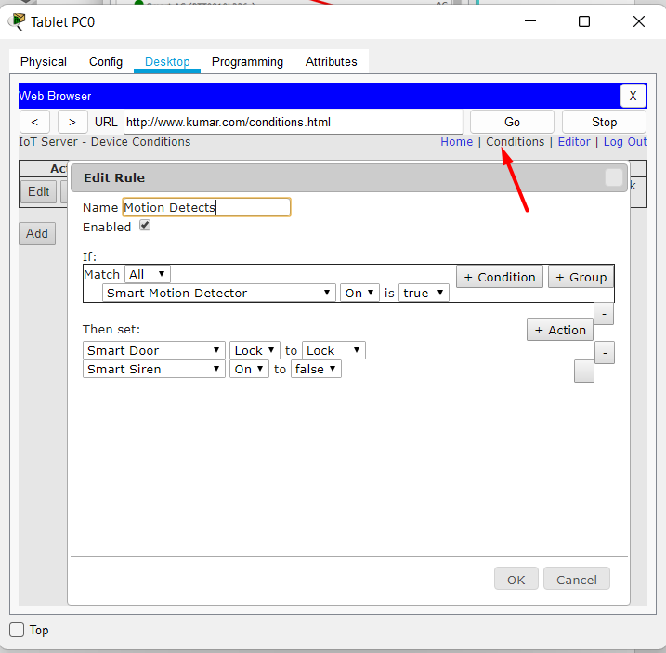

Figure 26: Motion detect condition

To check this condition first we had to turn on the siren and leave the front door on. Then when we turned on the motion detector the siren set off and the door got locked

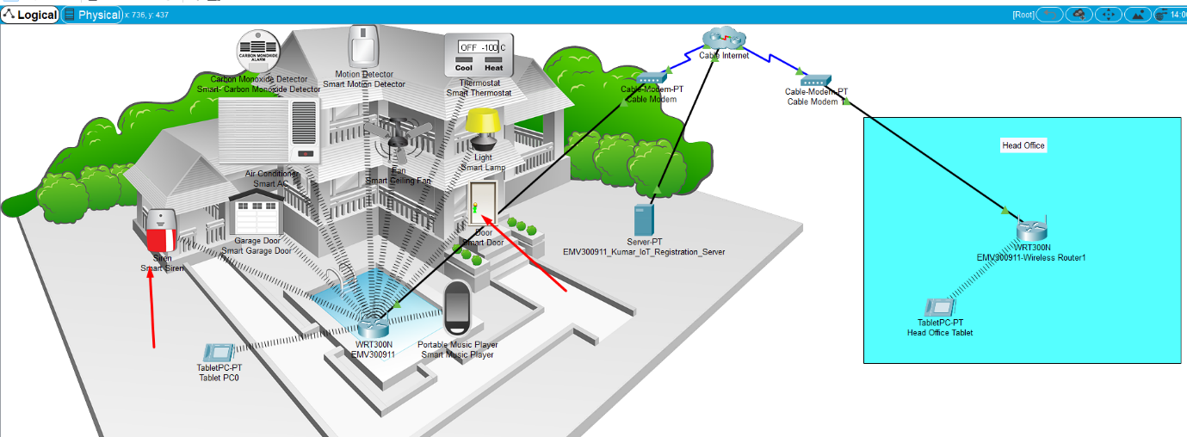

Figure 27: Matching the condition

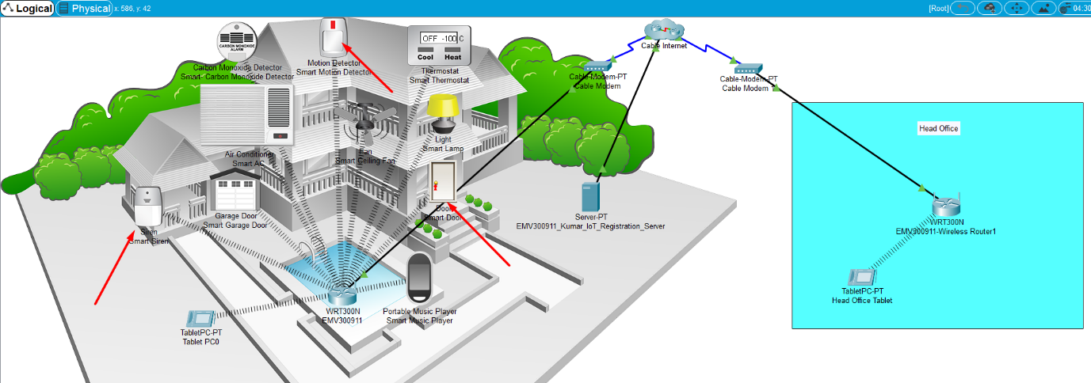

Figure 28: Motion-detect On, condition get success

## Increase the carbon monoxide level and open the garage door (it should also close when the level reduces).

To accomplish this, I have set the condition that when the carbon monoxide level increases by 20%, the garage door will open automatically and when it decreases by 15%, the door will close automatically.

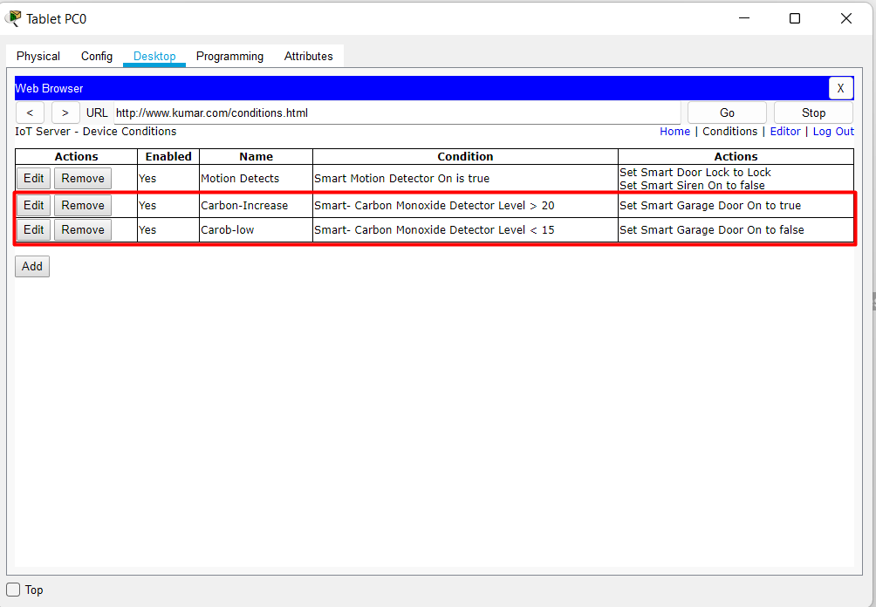

Figure 29: Carbon monoxide condition

To check this condition I have added the car to the workspace. In the image below, we can see clearly that the garage door opens automatically when the carbon monoxide level rises above 20%.

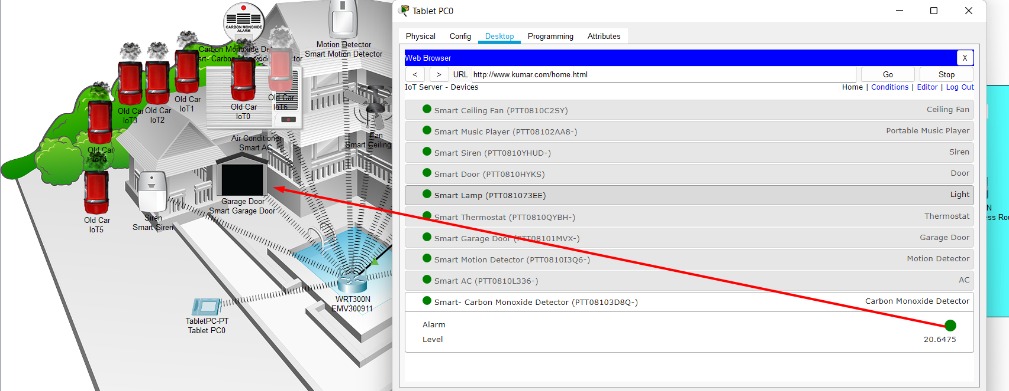

Similarly, when the carbon monoxide level decrease from 15% the garage door locked automatically.

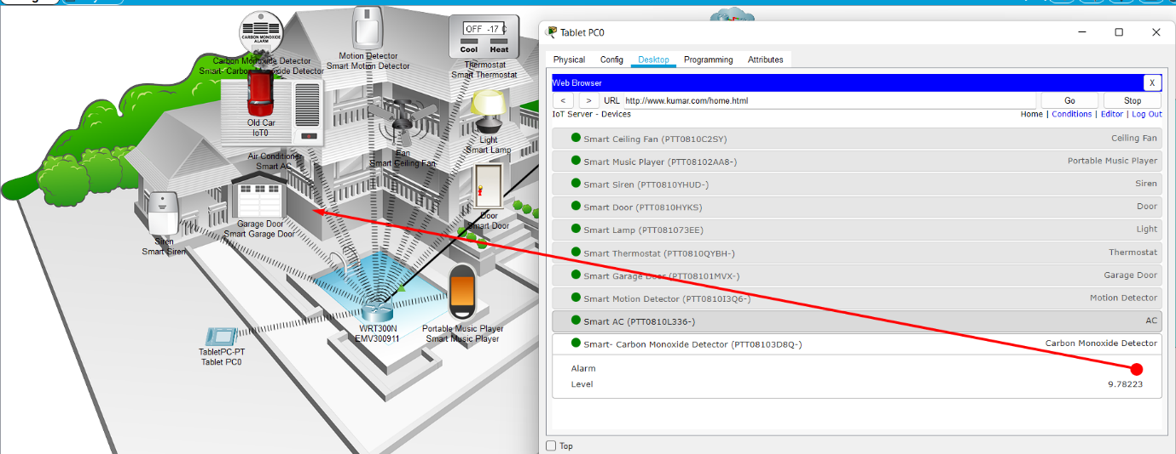

# References

*Packet tracer faqs* (2022) *Networking Academy*. CISCO. Available at <https://www.netacad.com/courses/packet-tracer/faq> (Accessed: January 15, 2023).

Cisco (2021) Configuration fundamentals configuration guide, Cisco Ios Release 15M&amp;T - ACL authentication of incoming RSH and RCP requests [Cisco IOS 15.5M&amp;T], Cisco. Cisco. Available at: <https://www.cisco.com/c/en/us/td/docs/ios-xml/ios/fundamentals/configuration/15mt/fundamentals-15-mt-book/cf-remote-shell.html> (Accessed: January 15, 2023).

Keary, T. (2019) *Ultimate Guide to packet tracer*, *ITPRC*. Available at: <https://www.itprc.com/packet-tracers/> (Accessed: January 17, 2023).

*Packet Tracer - Connect IoT Devices to a Registration Server* (2020) *YouTube*. YouTube. Available at: <https://www.youtube.com/watch?v=bPO7K_BaC9U> (Accessed: January 20, 2023).